**REACT JS PROJECT**

**SYNOPSIS:**

Zenith Tourism Hotspots in India is a website designed to provide travelers with comprehensive information about India's natural and cultural attractions. From the Himalayas to Kerala's backwaters, the platform offers detailed guides to various UNESCO World Heritage Sites. With its focus on adventure and exploration, Zenith aims to inspire travelers to discover the beauty and diversity of India.

**SOURCE CODE:**

**App.js**

import React from 'react';

import './App.css';

import { BrowserRouter as Router, Route, Link, Routes } from 'react-router-dom';

import Image from './images/logo.png';

import Home from './home.js';

import Natural from './natural.js';

import Cultural from './cultural.js';

import Mixed from './mixed.js';

import Contact from './contact.js';

import './image.css';

import './heading.css';

const App = () => {

  return(

    <div>

      <img src={Image} alt="logo"  className="images"></img>

      <h1 className="head"  align="center">ZENITH</h1>

    <Router>

      <nav>

        <ul>

          <li>

            <Link to="/">Home</Link>

          </li>

          <li>

            <Link to="/natural">Natural</Link>

          </li>

          <li>

            <Link to="/cultural">Cultural</Link>

          </li>

          <li>

            <Link to="/mixed">Mixed</Link>

          </li>

          <li>

            <Link to="/Contact">Contact</Link>

          </li>

        </ul>

      </nav>

      <Routes>

        <Route path="/" exact Component={Home} />

        <Route path="/natural" Component={Natural} />

        <Route path="/cultural" Component={Cultural} />

        <Route path="/mixed" Component={Mixed} />

        <Route path="/Contact" Component={Contact} />

      </Routes>

    </Router>

    </div>

  );

};

export default App;

**natural.js**

import React, { useState } from 'react';

import './App.css'; // Assuming styles are in this file

function Natural() {

  // State to track the visibility of info sections and which button was clicked

  const [selectedState, setSelectedState] = useState(null);

  // Function to handle button click and set the selected state

  const handleClick = (state) => {

    setSelectedState(state); // Show information based on the selected state

  };

  return (

    <div className="App">

      {/* Assam Button */}

      <button className="mainButton" onClick={() => handleClick('Assam')}>

        Assam

      </button>

      {/* West Bengal Button */}

      <button className="mainButton" onClick={() => handleClick('West Bengal')}>

      West Bengal

      </button>

      {/* Uttarakhand Button */}

      <button className="mainButton" onClick={() => handleClick('Uttarakhand')}>

      Uttarakhand

      </button>

      {/* Rajasthan Button */}

      <button className="mainButton" onClick={() => handleClick('Rajasthan')}>

        Rajasthan

      </button>

      {/* Himachal Pradesh Button */}

      <button className="mainButton" onClick={() => handleClick('Himachal Pradesh')}>

      Himachal Pradesh

      </button>

      {/* Karnataka Button */}

      <button className="mainButton" onClick={() => handleClick('Karnataka')}>

      Karnataka

      </button>

      {/* Rajasthan Information Section */}

      {selectedState === 'Rajasthan' && (

        <div className="info-section">

          <div>

            <p className="point">1. Keoladeo National Park</p>

            <img

              src="https://windows10spotlight.com/wp-content/uploads/2022/11/287b68e0c29d59260d7233cc30ceb007-1024x576.jpg"

              alt="keoladeo" width="500px"

            />

            <p>

            Keoladeo National Park, located in Rajasthan, India, is a UNESCO World Heritage Site renowned

            for being one of the world’s most important bird sanctuaries. Spanning about 29 square kilometers,

            the park is a mosaic of wetlands, woodlands, and grasslands, attracting over 370 species of birds,

            including migratory species like the Siberian crane. Originally a royal hunting ground, it was

            later converted into a protected area and is now a vital stopover for migratory birds. Keoladeo

            is also home to various mammals, reptiles, and amphibians, making it an important ecological

            zone in India.

            </p>

          </div>

        </div>

      )}

      {/* Assam Information Section */}

      {selectedState === 'Assam' && (

        <div className="info-section">

          <div>

            <p className="point">1. Kaziranga National Park</p>

            <img

              src="https://pyt-blogs.imgix.net/2020/06/Rhinos_in_KNP-scaled.jpg?auto=format&ixlib=php-3.3.0"

              alt="kazi" width="500px"

            />

            <p>

            Kaziranga National Park, located in Assam, India, is a UNESCO World Heritage Site renowned

            for its rich biodiversity and as a sanctuary for the world's largest population of the Indian

            one-horned rhinoceros. Spread across 430 square kilometers, the park features a diverse

            landscape of grasslands, wetlands, and dense forests, providing a haven for species like tigers,

            elephants, wild water buffalo, and various bird species. Kaziranga is also a designated Tiger

            Reserve and is celebrated for its conservation efforts. The Brahmaputra River and its

            tributaries enhance the park's natural beauty and ecological significance.

            </p>

          </div>

          <div>

            <p className="point">2. Manas Wildlife Sanctuary</p>

            <img

            src="https://www.india-a2z.com/images/manas1.jpg"

            alt="manas" width="500px"

            />

            <p>Manas Wildlife Sanctuary, located in Assam, India, is a UNESCO World Heritage Site and a

                renowned biosphere reserve. Nestled at the foothills of the Eastern Himalayas, it spans across

                grasslands, tropical forests, and wetlands, making it a biodiversity hotspot. The sanctuary is

                home to rare and endangered species like the Assam roofed turtle, golden langur, pygmy hog, and

                the Indian one-horned rhinoceros. It is also a designated Tiger Reserve and an Elephant Reserve.

                The Manas River, a major tributary of the Brahmaputra, flows through the sanctuary, adding to

                its scenic and ecological value.</p>

          </div>

        </div>

      )}

      {/* Karnataka Information Section */}

      {selectedState === 'Karnataka' && (

        <div className="info-section">

          <div>

            <p className="point">1. Western Ghats</p>

            <img

              src="https://www.bhavyaholidays.com/blogs/wp-content/uploads/2014/03/The-Western-Ghats-A-UNESCO-World-Heritage-Site.jpg"

              alt="wghats" width="500px"

            />

            <p>

            The Western Ghats, stretching across the states of Maharashtra, Karnataka, Kerala, and Tamil Nadu,

            is a UNESCO World Heritage Site and one of the world's eight "hottest hotspots" of biological

            diversity. This mountain range runs parallel to India’s western coast, forming a natural barrier

            to the monsoon winds and giving rise to diverse ecosystems, from tropical rainforests to montane

            grasslands. The Western Ghats are home to an extraordinary variety of flora and fauna, including

            many endemic species such as the Nilgiri tahr, lion-tailed macaque, and Malabar pied hornbill.

            This region also holds significant water resources, as numerous rivers, including the Godavari,

            Krishna, and Cauvery, originate here. The Western Ghats play a critical role in climate regulation,

            water supply, and biodiversity conservation in the region.

            </p>

          </div>

        </div>

      )}

      {/* Himachal Pradesh Information Section */}

      {selectedState === 'Himachal Pradesh' && (

        <div className="info-section">

            <div>

            <p className="point">1. Great Himalayan National Park Conservation Area</p>

            <img

            src="https://www.dev.greathimalayannationalpark.org/wp-content/uploads/2015/07/Forests04_980.jpg"

            alt="himalayan" width="500px"

            />

            <p>

            The Great Himalayan National Park Conservation Area, located in Himachal Pradesh, India, is a UNESCO

            World Heritage Site recognized for its stunning natural landscapes and rich biodiversity. Covering an

            area of over 1,100 square kilometers, the park is part of the Western Himalayas and encompasses pristine

            forests, alpine meadows, and snow-capped peaks. It is home to a wide range of endangered and endemic

            species, including the elusive snow leopard, Himalayan brown bear, blue sheep, and the Western tragopan.

            The park’s varied terrain and ecosystems provide critical habitats for both flora and fauna, making it a

            vital conservation area and a popular destination for trekkers and nature lovers.

            </p>

          </div>

        </div>

  )}

   {/* West Bengal Information Section */}

   {selectedState === 'West Bengal' && (

        <div className="info-section">

          <div>

            <p className="point">1. Sundarbans National Park</p>

            <img

              src="https://mediaindia.eu/wp-content/uploads/2018/03/gallery_photo_sundarbans-national-park-animal1467370769.jpg"

              alt="sundarbans" width="500px"

            />

            <p>

            Sundarbans National Park, located in West Bengal, India, is a UNESCO World Heritage Site and

            a crucial part of the world’s largest mangrove forest. It spans a vast area in the Sundarbans

            delta, where the Ganges, Brahmaputra, and Meghna rivers meet the Bay of Bengal. The park is

            famed for being home to the Bengal tiger and is a designated Tiger Reserve, playing a vital

            role in the conservation of this endangered species. The Sundarbans' unique ecosystem supports

            a wide variety of wildlife, including saltwater crocodiles, fishing cats, spotted deer, and

            numerous bird species. Its intricate network of tidal waterways, mudflats, and small islands

            makes it an ecological treasure, vital for both biodiversity and local livelihoods.

            </p>

          </div>

        </div>

      )}

    {/* Uttarakhand Information Section */}

   {selectedState === 'Uttarakhand' && (

        <div className="info-section">

          <div>

            <p className="point">1. Nanda Devi and Valley of Flowers National Parks</p>

            <img

              src="https://curlytales.com/wp-content/uploads/2023/06/valley-of-flowers-2.jpg"

              alt="nanda" width="500px"

            />

            <p>

            Nanda Devi and Valley of Flowers National Parks, located in Uttarakhand, India, form a UNESCO

            World Heritage Site known for their exceptional natural beauty and biodiversity. Nanda Devi

            National Park, dominated by the towering Nanda Devi Peak, offers rugged mountain landscapes,

            deep valleys, and rich alpine flora and fauna. The adjacent Valley of Flowers National Park is

            famous for its vibrant, seasonal display of endemic flowers that bloom in a high-altitude

            Himalayan valley, creating a breathtaking spectacle. Together, these parks support a wide

            variety of species, including the snow leopard, Himalayan black bear, and blue sheep, and are

            recognized for their unique ecosystems that showcase the beauty of the Western Himalayas.

            </p>

          </div>

        </div>

      )}

    </div>

  )

}

export default Natural;

**cultural.js**

import React, { useState } from 'react';

import './App.css'; // Assuming styles are in this file

function Cultural() {

  // State to track the visibility of info sections and which button was clicked

  const [selectedState, setSelectedState] = useState(null);

  // Function to handle button click and set the selected state

  const handleClick = (state) => {

    setSelectedState(state); // Show information based on the selected state

  };

  return (

    <div className="App">

      {/* Tamilnadu Button */}

      <button className="mainButton" onClick={() => handleClick('Tamilnadu')}>

        Tamilnadu

      </button>

      {/* Karnataka Button */}

      <button className="mainButton" onClick={() => handleClick('Karnataka')}>

        Karnataka

      </button>

      {/* Maharastra Button */}

      <button className="mainButton" onClick={() => handleClick('Maharastra')}>

        Maharastra

      </button>

      {/* Madhya Pradesh Button */}

      <button className="mainButton" onClick={() => handleClick('Madhya Pradesh')}>

        Madhya Pradesh

      </button>

      {/* West Bengal Button */}

      <button className="mainButton" onClick={() => handleClick('West Bengal')}>

        West Bengal

      </button>

      {/* Telangana Button */}

      <button className="mainButton" onClick={() => handleClick('Telangana')}>

        Telangana

      </button>

      {/* Goa Button */}

      <button className="mainButton" onClick={() => handleClick('Goa')}>

        Goa

      </button>

      {/* Uttar Pradesh Button */}

      <button className="mainButton" onClick={() => handleClick('Uttar Pradesh')}>

      Uttar Pradesh

      </button>

      {/* Assam Button */}

      <button className="mainButton" onClick={() => handleClick('Assam')}>

        Assam

      </button>

      {/* Rajasthan Button */}

      <button className="mainButton" onClick={() => handleClick('Rajasthan')}>

        Rajasthan

      </button>

      {/* Delhi Button */}

      <button className="mainButton" onClick={() => handleClick('Delhi')}>

        Delhi

      </button>

      {/* Gujarat Button */}

      <button className="mainButton" onClick={() => handleClick('Gujarat')}>

        Gujarat

      </button>

      {/* Bihar Button */}

      <button className="mainButton" onClick={() => handleClick('Bihar')}>

        Bihar

      </button>

      {/* Odisha Button */}

      <button className="mainButton" onClick={() => handleClick('Odisha')}>

      Odisha

      </button>

      {/* Chandigarh Button */}

      <button className="mainButton" onClick={() => handleClick('Chandigarh')}>

      Chandigarh

      </button>

      {/* Rajasthan Information Section */}

      {selectedState === 'Rajasthan' && (

        <div className="info-section">

          <div>

            <p className="point">1.The Jantar Mantar</p>

            <img

              src="https://farm6.staticflickr.com/5173/5522165246_b71c152675_z.jpg"

              alt="The Jantar Mantar" width="500px"

            />

            <p>

            The Jantar Mantar is a collection of astronomical observatories built in the 18th century by Maharaja Jai Singh II in various cities across India, with the most famous located in Jaipur and Delhi. Designed as a large-scale instrument to measure time, predict eclipses, and track celestial bodies, the observatory features a range of architectural structures, including the Samrat Yantra (the largest sundial), the Jaipur Yantra, and the Hemispherium. Each instrument is meticulously constructed to allow for precise astronomical observations, reflecting the advanced scientific knowledge of the era. A UNESCO World Heritage Site, Jantar Mantar stands as a testament to India's rich scientific heritage and its historical contributions to astronomy and mathematics.

            </p>

          </div>

          <div>

            <p className="point">2.Hill Forts of Rajasthan</p>

            <img

              src="https://i0.wp.com/www.rajasthandirect.com/wp-content/uploads/2012/11/Amer-Fort.jpg?fit=680%2C400&ssl=1"

              alt="Hill Forts of Rajasthan" width="500px"

            />

            <p>

            The Hill Forts of Rajasthan is a UNESCO World Heritage Site comprising six majestic fortifications built between the 5th and 18th centuries, showcasing the architectural brilliance and military prowess of the Rajput rulers. The forts include Amber Fort, renowned for its fusion of Hindu and Mughal styles; Jaigarh Fort, famous for housing the world's largest cannon on wheels; Nahargarh Fort, perched on the Aravalli hills with stunning frescoes; Kumbhalgarh Fort, known for its massive walls and the second-longest fortification in the world; Chittorgarh Fort, a symbol of Rajput valor featuring numerous palaces and temples; and Ranthambore Fort, located within Ranthambore National Park, reflecting rich historical significance. Together, these forts represent Rajasthan's cultural heritage and attract visitors with their impressive architecture and historical narratives.

            </p>

          </div>

          <div>

            <p className="point">3.Jaipur City</p>

            <img

              src="https://assets.vogue.in/photos/5ce41ea8b803113d138f5cd2/2:3/w_2560%2Cc_limit/Jaipur-Travel-Shopping-Restaurants.jpg"

              alt="Jaipur City" width="500px"

            />

            <p>

            Jaipur, the capital city of Rajasthan, India, is renowned for its rich history, vibrant culture, and stunning architecture, earning it the nickname "Pink City" due to the distinct color of its buildings. Founded in 1727 by Maharaja Sawai Jai Singh II, Jaipur was one of the earliest planned cities in India, featuring a grid layout and wide streets. The city is famous for its remarkable landmarks, including the Hawa Mahal (Palace of Winds), Amber Fort, City Palace, and the Jantar Mantar observatory, which is a UNESCO World Heritage Site. Jaipur's colorful bazaars, such as Johari Bazaar and Bapu Bazaar, are bustling with traditional crafts, jewelry, and textiles, reflecting the region's artistic heritage. As a part of the Golden Triangle tourist circuit, Jaipur attracts visitors from around the world, offering a glimpse into Rajasthan's royal past, vibrant culture, and architectural marvels

            </p>

          </div>

        </div>

      )}

      {/* Assam Information Section */}

      {selectedState === 'Assam' && (

        <div className="info-section">

          <div>

            <p className="point">1.Moidams</p>

            <img

              src="https://nagalandpage.com/wp-content/uploads/2024/07/Maidams.jpg"

              alt="Assam" width="500px"

            />

            <p>

            The Moidams, also known as the mound-burial system of the Ahom Dynasty, are significant archaeological sites located in Assam, India, reflecting the rich cultural heritage and funerary practices of the Ahom people who ruled the region for nearly 600 years (1228–1826). These earthen mounds serve as royal tombs for Ahom kings, queens, and other dignitaries, typically situated in a serene landscape surrounded by forests. Each Moidam is marked by a rectangular structure, often featuring intricate carvings and traditional designs that represent the deceased's status and achievements. The most notable Moidams are found in Sivasagar, the former capital of the Ahom Kingdom, including the Moidams of King Rudra Singha and King Chandra Kanta Singha. These burial sites not only highlight the architectural and artistic skills of the Ahoms but also serve as important cultural and historical landmarks, reflecting the dynasty's unique blend of indigenous and Buddhist influences. The Moidams are recognized for their archaeological significance, providing insights into the social and political history of Assam, and they contribute to the rich tapestry of India's diverse cultural heritage.

            </p>

          </div>

        </div>

      )}

      {/* Uttar Pradesh Information Section */}

      {selectedState === 'Uttar Pradesh' && (

        <div className="info-section">

          <div>

            <p className="point">1.Taj mahal </p>

            <img

              src="https://www.coolkidfacts.com/wp-content/uploads/2022/11/Taj-Mahal.jpg"

              alt="Uttar Pradesh" width="500px"

            />

            <p>

                The Taj Mahal lit. is an ivory-white marble mausoleum on the right bank of the river Yamuna in Agra, Uttar Pradesh, India. It was commissioned in 1631 by the fifth Mughal emperor, Shah Jahan  to house the tomb of his beloved wife, Mumtaz Mahal; it also houses the tomb of Shah Jahan himself. The tomb is the centrepiece of a 17-hectare (42-acre) complex, which includes a mosque and a guest house, and is set in formal gardens bounded on three sides by a crenellated wall.

            </p>

          </div>

          <div>

            <p className="point">2.Agra fort</p>

            <img

              src="https://asi.nic.in/images/agrafort1.jpg"

              alt="Agra fort" width="500px"

            />

            <p>

            The Agra Fort (Qila Agra) is a historical fort in the city of Agra, also known as Agra's Red Fort. Mughal emperor Humayun was crowned at this fort in 1530. It was later renovated by the Mughal emperor Akbar from 1565 and the present-day structure was completed in 1573. It served as the main residence of the rulers of the Mughal dynasty until 1638, when the capital was shifted from Agra to Delhi. It was also known as the "Lal-Qila" or "Qila-i-Akbari".[1] Before being captured by the British, the last Indian rulers to have occupied it were the Marathas. In 1983, the Agra fort was inscribed as a UNESCO World Heritage Site because of its importance during Mughal rule.[2] It is about 2.5 kilometers (1.6 mi) northwest of its more famous sister monument, the Taj Mahal. The fort can be more accurately described as a walled city. It was later renovated by Shah Jahan.

            </p>

          </div>

          <div>

            <p className="point">3.Fatehpur Sikri</p>

            <img

              src="https://www.rajasthanbhumitours.com/blog/wp-content/uploads/2024/08/Fatehpur-Sikri-The-Forgotten-Capital-of-Mughal-Grandeur.jpg"

              alt="Fatehpur Sikri" width="500px"

            />

            <p>

            Fatehpur Sikri, located near Agra, India, was built by the Mughal Emperor Akbar in the late 16th century and served as the empire's capital for about 14 years before being abandoned due to water scarcity. The city is known for its stunning Mughal architecture, with key monuments such as the Buland Darwaza, Jama Masjid, Panch Mahal, Diwan-i-Khas, and the Tomb of Salim Chishti. A blend of Indian, Persian, and Islamic styles, Fatehpur Sikri reflects Akbar's vision of a utopian society and remains a UNESCO World Heritage Site, showcasing the grandeur of the Mughal era.

            </p>

          </div>

        </div>

      )}

      {/* Delhi Information Section */}

      {selectedState === 'Delhi' && (

        <div className="info-section">

          <div>

            <p className="point">1.Humayun's Tomb</p>

            <img

              src="https://images.mid-day.com/images/images/2024/jul/humayunstomb_d.jpg"

              alt="Humayun's Tomb" width="500px"

            />

            <p>

            Humayun’s Tomb, Delhi is the first of the grand dynastic mausoleums that were to become synonyms of Mughal architecture with the architectural style reaching its zenith 80 years later at the later Taj Mahal. Humayun’s Tomb stands within a complex of 27.04 ha. that includes other contemporary, 16th century Mughal garden-tombs such as Nila Gumbad, Isa Khan, Bu Halima, Afsarwala, Barber’s Tomb and the complex where the craftsmen employed for the Building of Humayun’s Tomb stayed, the Arab Serai.

            </p>

          </div>

          <div>

            <p className="point">2. Qutb Minar</p>

            <img

              src="https://www.touryatras.com/wp-content/uploads/slider/cache/1049915bdd27d9704cf84a09458b2567/Qutub-minar-delhi-image-scaled.jpg"

              alt="Qutb Minar" width="500px"

            />

            <p>

            The Qutb Minar and its Monuments in Delhi, a UNESCO World Heritage Site, showcase the Indo-Islamic architectural brilliance of the early Delhi Sultanate. The centerpiece, Qutb Minar, is a 73-meter tall victory tower built in the 13th century by Qutb-ud-din Aibak, accompanied by the Quwwat-ul-Islam Mosque, constructed using materials from Hindu and Jain temples. The complex includes the rust-resistant Iron Pillar from the Gupta period, the Alai Darwaza gateway with intricate stonework, the unfinished Alai Minar, and the Tomb of Iltutmish. This site represents the fusion of Hindu, Jain, and Islamic architectural elements, marking the rise of Islamic rule in India.

            </p>

          </div>

          <div>

            <p className="point">3.Red Fort</p>

            <img

              src="https://www.abhibus.com/blog/wp-content/uploads/2023/08/Red-Fort-Delhi.jpg"

              alt="Red Fort" width="500px"

            />

            <p>

            The Red Fort, also known as Lal Qila, is a historic fortification located in the heart of Delhi, India, and is a UNESCO World Heritage Site. Commissioned by Mughal Emperor Shah Jahan in 1638 as the royal palace of the Mughal dynasty, the fort is renowned for its stunning red sandstone architecture and impressive defensive walls, which stretch over 2 kilometers. Notable structures within the fort include the Diwan-i-Aam (Hall of Public Audience), the Diwan-i-Khas (Hall of Private Audience), and the beautiful gardens of Mumtaz Mahal. The Red Fort symbolizes India's rich history and architectural brilliance and serves as a national icon, particularly during India's Independence Day celebrations when the Prime Minister addresses the nation from its ramparts.

            </p>

          </div>

        </div>

      )}

      {/* Gujarat Information Section */}

      {selectedState === 'Gujarat' && (

        <div className="info-section">

          <div>

            <p className="point">1.Rani-ki-Vav</p>

            <img

              src="https://www.india.com/wp-content/uploads/2018/08/Rani-ki-Vav1.jpg"

              alt="Rani-ki-Vav" width="500px"

            />

            <p>

            Rani-ki-Vav, located in Patan, Gujarat, is an exquisite stepwell and a UNESCO World Heritage Site, celebrated for its intricate architectural design and historical significance. Built in the 11th century by Queen Udayamati in memory of her husband, King Bhimdev I of the Solanki dynasty, this stepwell is renowned for its elaborate carvings, intricate sculptures, and a unique layout that reflects the advanced engineering of the time. The structure features seven levels of stairs adorned with over 800 beautifully detailed sculptures depicting deities, dancers, and mythological figures, showcasing the artistry and craftsmanship of the period. Rani-ki-Vav served both as a functional water reservoir and a cool retreat in the arid climate, symbolizing the cultural and architectural heritage of Gujarat and offering visitors a glimpse into the region's rich history.

            </p>

          </div>

          <div>

            <p className="point">2.Champaner-Pavagadh Archaeological Park</p>

            <img

              src="https://i0.wp.com/travelshoebum.com/wp-content/uploads/2018/10/img_3487.jpg?resize=1200%2C1600&ssl=1"

              alt="Champaner-Pavagadh Archaeological Park" width="500px"

            />

            <p>

            The Champaner-Pavagadh Archaeological Park, a UNESCO World Heritage Site in Gujarat, India, is renowned for its historical and architectural significance, showcasing monuments, temples, and fortifications dating from the 8th to the 16th centuries. Founded by the Mughal Sultan Mahmud Begada, the park features remarkable structures like the intricately designed Jami Masjid, tombs, stepwells, and palaces that exemplify the fusion of Hindu, Jain, and Islamic architectural styles. Pavagadh Hill houses the important Kalika Mata Temple, attracting Hindu pilgrims and offering stunning views of the surrounding landscape. The park not only highlights the region's rich cultural heritage and historical syncretism but also boasts a diverse natural environment, making it a significant destination for both history enthusiasts and nature lovers.

            </p>

          </div>

          <div>

            <p className="point">3.Ahmadabad</p>

            <img

              src="https://upload.wikimedia.org/wikipedia/commons/thumb/9/99/Sheth_Hutheesinh_Temple.jpg/640px-Sheth_Hutheesinh_Temple.jpg"

              alt="Ahmadabad" width="500px"

            />

            <p>

            Ahmedabad, the largest city in the state of Gujarat, India, is a vibrant metropolis known for its rich history, cultural heritage, and modern economic significance. Founded in the 15th century by Sultan Ahmed Shah, the city features a blend of Indo-Islamic architecture, with notable landmarks like the Sabarmati Ashram, which served as a pivotal base for Mahatma Gandhi during India's independence movement. Ahmedabad is also home to the UNESCO World Heritage Site of Walled City, showcasing intricately carved wooden havelis, stepwells, and beautiful mosques, reflecting the city’s historical wealth. The city has emerged as an important economic and industrial hub, particularly in textiles and information technology, while also being recognized for its vibrant food scene and rich cultural traditions, making it a key destination for tourists and business travelers alike.

            </p>

          </div>

          <div>

            <p className="point">4.Dholavira</p>

            <img

              src="https://blogger.googleusercontent.com/img/b/R29vZ2xl/AVvXsEhu9_7e-Ro3Y_FNaKiNXkAgAYsxurBirC2JKvADQ1W-z3H8TL9xHi4zNFwu9L5_ungHhY8_dzLBT-haNQz9gC00_DS8shFabsgLSCG9m4YBGLOODRb4jWiAdYJ-EHLqqH_TMhn0ojdYF0M/s734/dhola1.jpg"

              alt="Dholavira" width="500px"

            />

            <p>

            Dholavira, a prominent archaeological site located on the arid island of Khadir in Gujarat, India, is one of the most significant cities of the Harappan Civilization, dating back to approximately 4500 years ago. Recognized as a UNESCO World Heritage Site, Dholavira is notable for its sophisticated urban planning, advanced water conservation systems, and impressive architectural features, including large reservoirs, stepwells, and well-organized streets. The city is distinguished by its unique layout, consisting of a citadel, a middle town, and a lower town, all fortified with massive stone walls. Dholavira also features remarkable craftsmanship, as evidenced by its intricate seals, jewelry, and pottery. This ancient city offers valuable insights into the social, economic, and cultural aspects of the Harappan Civilization, highlighting its ingenuity and resilience in adapting to a challenging environment.

            </p>

          </div>

        </div>

      )}

      {/* Bihar Information Section */}

      {selectedState === 'Bihar' && (

        <div className="info-section">

          <div>

            <p className="point">1.Mahabodhi Temple</p>

            <img

              src="https://akkaias.com/uploads/images/outlooktraveller.jpg"

              alt="Mahabodhi Temple" width="500px"

            />

            <p>

            The Mahabodhi Temple, located in Bodh Gaya, Bihar, India, is a UNESCO World Heritage Site and one of the most revered Buddhist pilgrimage sites, marking the spot where Siddhartha Gautama attained enlightenment under the Bodhi tree around 500 BCE. The temple features a tall pyramidal structure with a central tower, housing a seated Buddha statue, and is surrounded by significant locations like the Vajrasana (the "Diamond Throne") and the sacred Bodhi tree, a descendant of the original. Built initially by Emperor Ashoka in the 3rd century BCE and later reconstructed in the 5th and 6th centuries CE, the temple complex also includes various stupas and monasteries representing different Buddhist traditions from around the world, symbolizing peace, compassion, and the path to spiritual awakening.

            </p>

            </div>

            <div>

            <p className="point">2.Nalanda Mahavihara at Nalanda</p>

            <img

              src="https://www.culturalindia.net/iliimages/Nalanda-(Mahavihara)-ili-56-img-1.jpg"

              alt="Nalanda Mahavihara " width="500px"

            />

            <p>

            Nalanda Mahavihara, located in Nalanda, Bihar, is an ancient center of learning and a UNESCO World Heritage Site, renowned as one of the world's first residential universities, established in the 5th century CE. This revered Buddhist monastic complex attracted thousands of scholars and students from across Asia, including notable figures like Xuanzang and I-Tsing, who came to study and teach various subjects, including philosophy, medicine, and astronomy. The site encompasses extensive ruins of temples, monasteries, and classrooms, showcasing remarkable architectural features with intricate carvings and brick structures. Nalanda played a pivotal role in the spread of Buddhism and the exchange of knowledge, symbolizing India's rich intellectual heritage, and continues to be a significant site for historians and pilgrims alike.

            </p>

          </div>

        </div>

      )}

      {/* Odisha Information Section */}

      {selectedState === 'Odisha' && (

        <div className="info-section">

          <div>

            <p className="point">1.Sun Temple</p>

            <img

              src="https://victoriaclubhotel.com/Images/blog/konark.jpg"

              alt="Sun Temple" width="500px"

            />

            <p>

            Konark is a medium town in the Puri district in the state of Odisha, India. It lies on the coast by the Bay of Bengal, 65 kilometres from the capital of the state, Bhubaneswar.[1] It is the site of the 13th-century Sun Temple, also known as the Black Pagoda, built in black granite during the reign of Narasinghadeva-I. The temple is a World Heritage Site.[2] The temple is now mostly in ruins, and a collection of its sculptures is housed in the Sun Temple Museum, which is run by the Archaeological Survey of India.

            </p>

            </div>

        </div>

      )}

      {/* Chandigarh Information Section */}

      {selectedState === 'Chandigarh' && (

        <div className="info-section">

          <div>

            <p className="point">1.The Architectural Work of Le Corbusier </p>

            <img

              src="https://cdn.thespaces.com/wp-content/uploads/2020/04/Chandigarh_RC_6.jpg"

              alt="The Architectural Work of Le Corbusier" width="500px"

            />

            <p>

            The Architectural Work of Le Corbusier is a UNESCO World Heritage Site that encompasses a collection of 17 significant buildings designed by the influential Swiss-French architect Charles-Édouard Jeanneret, known as Le Corbusier. Spanning multiple countries, including France, India, and Switzerland, this site showcases Le Corbusier's innovative approach to modern architecture, characterized by functionalism, the use of reinforced concrete, and an emphasis on open spaces. Key projects include the iconic Villa Savoye in Poissy, France, which exemplifies his "Five Points of a New Architecture," and the Unité d'Habitation in Marseille, a pioneering example of urban housing. In India, his design of Chandigarh as a modernist city demonstrates his vision for urban planning and architecture, integrating nature and functionality. Le Corbusier's work has had a profound impact on architectural design, promoting the principles of modernism and influencing generations of architects worldwide.

            </p>

            </div>

        </div>

      )}

      {/* Tamilnadu Information Section */}

      {selectedState === 'Tamilnadu' && (

        <div className="info-section">

          <div>

            <p className="point">1. Group of Monuments at Mahabalipuram</p>

            <img

              src="https://c.ndtvimg.com/2020-08/gom2ebv_mahabalipuram_295x200_20_August_20.jpg"

              alt="mahabalipuram" width="500px"

            />

            <p>

            The Group of Monuments at Mahabalipuram, also known as Mamallapuram, is one of the most

            famous UNESCO Sites in Tamil Nadu. Located along the Coromandel Coast, this site dates back

            to the 7th and 8th centuries and is a testament to the architectural genius of the Pallava

            dynasty.The monuments at Mahabalipuram are not just significant for their historical value

             but also for their artistic beauty. Visiting this UNESCO Site in Tamil Nadu provides an

             opportunity to witness some of the finest examples of ancient Indian stone architecture.

            </p>

          </div>

          <div>

            <p className="point">2. Great Living Chola Temples</p>

            <img

              src="http://www.tnpscthervupettagam.com/wp-content/uploads/2017/12/1-8.jpg"

              alt="chola" width="500px"

            />

            <p>

            The Great Living Chola Temples are another remarkable set of UNESCO Sites in Tamil Nadu.

            These temples were built during the Chola dynasty, one of the longest-ruling dynasties in

             South India. The temples at Thanjavur, Gangaikonda Cholapuram, and Darasuram represent the

              zenith of Chola architecture and are revered for their grandeur and intricate detailing.

            </p>

          </div>

        </div>

      )}

      {/* Karnataka Information Section */}

      {selectedState === 'Karnataka' && (

        <div className="info-section">

          <div>

            <p className="point">1. Hampi</p>

            <img

              src="https://images.lonelyplanetitalia.it/uploads/shutterstockrf-110806538?q=80&p=slider&s=95542fa36319bb5601a0582666f94aac"

              alt="hampi" width="500px"

            />

            <p>The Group of Monuments in Hampi, in the Vijayanagara District were included in the World

                Heritage Sites in 1986. Hampi, was the erstwhile capital of the Vijayanagara Empire.

                he empire is considered one of the most powerful and influential rules in the region

                dating from 1343-1565. Today, the ruins of the city bear testimony to the glorious past,

                with stunning architecture, monuments and sculptures. With more than 500 temples, halls,

                water reservoirs, mandapas, bastions, treasury buildings, royal complexes and more,

                the ruins and monuments of Hampi are an archeological and historical treasure. </p>

          </div>

          <div>

            <p className="point">2. Pattadakal</p>

            <img

              src="http://www.realbharat.org/wp-content/uploads/2016/02/pattadakal-monuments-172873_960_720-pixabay2.jpg"

              alt="pattadakal" width="500px"

            />

             <p>

             The Group Monuments of Pattadakal are located in the Bagalkot district of Karnataka.

             The structures and monuments here were built during the reign of the Chalukya dynasty in

             18th century CE. This site was included in the World Heritage Sites in 1987. Pattadakal was

             also known as the ‘City of Crown Rubies’ and the village is situated on the banks of the

             Malaprabha River. Pattadakal village itself has 9 temples and a Jain sanctuary. The temples

             are a striking example of the Badami Chalukya architectural style.

            </p>

          </div>

          <div>

            <p className="point">3. Hoysala Temples</p>

            <img

              src="https://www.tourmyindia.com/socialimg/hoysala-temples-tour.jpg"

              alt="hoysala" width="500px"

            />

            <p>

            The Hoysala Temples are the latest and most recent entry on the World Heritage List from

            Karnataka. The temples were a part of the Tentative List since 2014, however they officially

            became a part of the List in September 2023. The Sacred Ensembles of Hoysala include the

            temples of Chennakesava, Hoyasaleshwara and Keshava Temple situated in Belur, Halebid and

            Somnathpur in Karnataka. The Hoysala Temples date to between the 12th and 13th century,

            built during the reign of the Hoysala Empire and are a classic example of Dravidian and

            Nagara style of architecture.

            </p>

          </div>

        </div>

      )}

      {/* Maharastra Information Section */}

      {selectedState === 'Maharastra' && (

        <div className="info-section">

          <div>

            <p className="point">1. Ellora Caves</p>

            <img

              src="https://www.tripsavvy.com/thmb/tTPVCtmmRr8gxd7oowt4m57Egd4=/3000x2000/filters:no_upscale():max_bytes(150000):strip_icc()/GettyImages-583958200-03a09c835d52423eb2d29dc624412908.jpg"

              alt="ellora" width="500px"

            />

            <p>

            Ellora Caves, located near Aurangabad in Maharashtra, are a group of 34 ancient monasteries

            and temples carved into a high basalt cliff. These magnificent caves span over 2 km and date

            back to AD 600 to 1000. The Ellora complex showcases the civilization of ancient India, where

            followers of Buddhism, Hinduism, and Jainism worked together, showing a spirit of coexistence

            and religious tolerance. The caves were added to UNESCO world heritage site list for several

            reasons. Firstly, they are a unique artistic achievement, displaying an outstanding level of

            creativity and skill. Secondly, the caves offer a glimpse into the ancient Indian civilization,

            with monuments dating back to over a thousand years. Lastly, the three religions coexisted and

            established their sanctuaries in one place, emphasizing their universal value.

            </p>

          </div>

          <div>

            <p className="point">2. Ajanta Caves</p>

            <img

              src="https://upload.wikimedia.org/wikipedia/commons/a/a4/Cave_26%2C_Ajanta.jpg"

              alt="ajanta" width="500px"

            />

            <p>

            The Ajanta Caves, an extraordinary UNESCO World Heritage Site, holds a remarkable

            historical and artistic significance. These ancient caves are situated on a

            vertical cliff above the river Waghora in the hills of Ajanta. There are thirty

            caves in total, including the unfinished ones, out of which five are chaityagrihas

            or sanctuaries, and the rest are sangharamas or monasteries. The Ajanta Caves stand

            as a testament to the artistic and spiritual richness of ancient India, drawing

            visitors from around the world to witness its magnificence and understand the

            historical and religious significance it holds.

            </p>

          </div>

          <div>

            <p className="point">3. Chhatrapati Shivaji Maharaj Terminus</p>

            <img

            src="https://imgcld.yatra.com/ytimages/image/upload/v1461146086/Mumbai-Chhatrapati_Shivaji_Terminus1.jpg"

            alt="shivaji" width="500px"

            />

            <p>

            The Chhatrapati Shivaji Maharaj Terminus is an extraordinary railway station,

            displaying a fusion of British, Italian, and Indian architectural styles. It

            showcases intricate 3D stone carvings of animals, flora, and fauna, along with

            impressive arches and beautiful rose windows. The building is made of various

            materials like yellow malad stones, Italian marble, polished granite, and white

            limestone, adding to its splendor. The station is a historic symbol of Mumbai as

            a major port city and a significant commercial hub during the British colonial era.

            It reflects the economic prosperity of city at that time.

            </p>

          </div>

          <div>

            <p className="point">4. Sahyadri mountain range</p>

            <img

            src="https://voiceofadventure.com/wp-content/uploads/2021/03/Rajmachi_viewpoint-e1615806373480-1024x687.jpg"

            alt="sahyadri" width="500px"

            />

            <p>

            The Western Ghats, also known as the Sahyadri mountain range, older than the Himalayas,

            are a chain of mountains running along India’s western coast. They are very special

            because of their unique influence on the weather and climate in the region. The Ghats

            play a significant role in the Indian monsoon system, making the tropical climate of

            the area more moderate. This makes the Western Ghats a great example of the monsoon

            system worldwide.

            </p>

          </div>

          <div>

            <p className="point">5. Elephanta Caves</p>

            <img

            src="https://cdn.britannica.com/94/99694-050-29ABD6B2/Sadashiva-relief-cave-temple-India-Elephanta-Island.jpg"

            alt="elephanta" width="500px"

            />

            <p>

            The Elephanta Caves, also known as the ‘City of Caves,’ are located on Elephanta Island

            near Mumbai, in Western India. These ancient caves hold a mesmerizing collection of rock

            art connected to the worship of Lord Shiva. Dating back to around the 5th to 6th centuries

            AD, these remarkable caves showcase some of the finest examples of Indian art and architecture.

            Elephanta Caves have earned their place on UNESCO World Heritage site List for several reasons.

            Firstly, the fifteen large sculptures surrounding the Shiv linga in the main cave are considered

            one of the greatest examples of Indian art, specifically devoted to the cult of Lord Shiva.

            Secondly, these caves are a pinnacle of rock-architecture in western India, showcasing colossal

            sculptures and artistic creations of unparalleled beauty.

            </p>

          </div>

        </div>

      )}

      {/* Madhya Pradesh Information Section */}

      {selectedState === 'Madhya Pradesh' && (

        <div className="info-section">

            <div>

            <p className="point">1.Sanchi Stupa</p>

            <img

            src="https://tse2.mm.bing.net/th?id=OIP.oKLo_8JKuFBqan1dBAQPPwHaEM&pid=Api&P=0&h=180"

            alt="stupa" width="500px"

            />

            <p>

            The main attraction of Sanchi is the Great Stupa, believed to be the first monument to be erected

            in Sanchi in the third century BC. It is also one of the oldest stone structures in India and is

            considered one of the finest examples of Buddhist architecture and art, built by the Mauryan emperor

            Ashoka. The stupa has a hemispherical dome that is surrounded by a railing and four gateways, each

            adorned with intricate carvings and sculptures depicting stories from the life of Buddha. The Stupa

            is a UNESCO World Heritage site and is a must-visit for anyone interested in history and architecture.

            </p>

          </div>

          <div>

            <p className="point">2. Khajuraho Group of Monuments</p>

            <img

            src="https://4.bp.blogspot.com/-k3psoBZcLow/Usq9kbf408I/AAAAAAAAAcM/DzCbsYo42Sg/w1200-h630-p-k-no-nu/May-21_5_Khajuraho-Temples.jpg"

            alt="khajuraho" width="500px"

            />

            <p>

            Built in the mediaeval century by the Chandela Dynasty, the UNESCO site of 'Khajuraho Group of Monuments'

            is famous for its Nagara-Style architecture and graceful sculptures of nayikas (Hindu Mythological female

            protagonists) and deities. The splendour of the intricate statues is one of the reasons that makes it a

            popular site to visit among tourists. Built between 950-1050 AD by the Chandela Dynasty, these temples

            represent various forms of meditation, spiritual teachings and relationships through stimulating art.

            The temples are famous for their craftsmanship that consist of splendid demonstrations of fine sculptures

            and exceptional architectural skill, making them one of the most stunning UNESCO World Heritage Sites

            in India.

            </p>

          </div>

          <div>

            <p className="point">3. Bhimbetka rock shelters</p>

            <img

            src="https://www.gosahin.com/go/p/e/1532775640_Bhimbetka-Rock-Shelters1.jpg"

            alt="rock" width='500px'

            />

            <p>

            An archaeological treasure, Bhimbetka has around 243 rock shelters and have earned the honour of UNESCO

            World Heritage Site. The paintings found in the rock shelters here have a striking resemblance to the

            ones discovered in Kakadu National Park in Australia; to the cave paintings of Bushmen in Kalahari

            Desert and Upper Palaeolithic Lascaux cave paintings in France.

            </p>

          </div>

        </div>

  )}

   {/* West Bengal Information Section */}

   {selectedState === 'West Bengal' && (

        <div className="info-section">

          <div>

            <p className="point">1. Santiniketan</p>

            <img

              src="https://media.cntraveller.in/wp-content/uploads/2018/05/Shantiniketan3.jpg"

              alt="santi" width="500px"

            />

            <p>

            Santiniketan, West Bengal has been inscribed on UNESCO’s list of World Heritage Sites during

            the ongoing 45th session of the UNESCO World Heritage Committee in Riyadh, Kingdom of Saudi

            Arabia. Santiniketan is India's 41st UNESCO World Heritage Site. It is an ensemble of

            historic buildings, landscapes and gardens, pavilions, artworks, and continuing educational

            and cultural traditions that together express its Outstanding Universal Value.

            </p>

          </div>

        </div>

      )}

    {/* Telangana Information Section */}

   {selectedState === 'Telangana' && (

        <div className="info-section">

          <div>

            <p className="point">1. Ramappa temple</p>

            <img

              src="https://www.surfacesreporter.com/myuploads/ramappa-temple-more.jpeg"

              alt="ramappa" width="500px"

            />

            <p>

            About 200 km north-east of Hyderabad, capital of Telangana, in the village of Palampet, stands

            a marvel of Indian history, the Ramappa temple, which is also known as Rudreshswara temple.

            This medieval wonder dates back to 1213 AD and was built by the Kakatiya ruler Kakati Ganapati

            Deva, but the temple is named after its chief architect, Ramappa, making it perhaps the only

            temple in India to be known by the name of its sculptor. It took almost over 40 years to

            construct the temple.On June 25, 2021, the United Educational, Scientific and Cultural

            Organization (UNESCO) declared the Ramappa temple as a World Heritage Site, making it the 40th

            such site in India.

            </p>

          </div>

        </div>

      )}

    {/* Goa Information Section */}

    {selectedState === 'Goa' && (

        <div className="info-section">

          <div>

            <p className="point">1. The Basilica of Bom Jesus</p>

            <img

              src="https://static.toiimg.com/photo/92691407/Basilica-of-Bom-Jesus.jpg?width=748&resize=4"

              alt="basilica" width="500px"

            />

            <p>

            The Basilica of Bom Jesus is a UNESCO World Heritage Site located in the state of Goa, India.

            It is a Roman Catholic church that was built in the late 16th century and is one of the most famous

            and revered churches in India. The church is famous for housing the mortal remains of St. Francis

            Xavier, a Jesuit missionary who played a significant role in spreading Christianity in India during

            the 16th century. St. Francis Xavier is considered one of the greatest Christian missionaries and

            saints in the Catholic Church, and his body is displayed in a silver casket inside the church.

            </p>

          </div>

          <div>

            <p className="info-section">2. The Historic City of Panaji </p>

            <img

            src="https://www.tripsavvy.com/thmb/iwREDHt-7WIOA0FGmNNiSvkz2j8=/1500x0/filters:no_upscale():max_bytes(150000):strip_icc()/GettyImages-535497183-581ee24b3df78cc2e847afdf.jpg"

            alt="panaji" width="500px"

            />

            <p>

            The historic city of Panaji, also known as Panjim, is the capital city of Goa, a state in western India.

            Panaji has a rich history, dating back to the 16th century when it was founded by the Adil Shahi dynasty.

            Over the years, the city has been ruled by various dynasties and colonial powers, including the Portuguese,

            who occupied Goa for over 400 years.

            </p>

            </div>

        </div>

      )}

    </div>

  )

}

export default Cultural;

**mixed.js**

import React, { useState } from 'react';

import './App.css'; // Assuming styles are in this file

function Mixed() {

  // State to track the visibility of info sections and which button was clicked

  const [selectedState, setSelectedState] = useState(null);

  // Function to handle button click and set the selected state

  const handleClick = (state) => {

    setSelectedState(state); // Show information based on the selected state

  };

  return (

    <div className="App">

      {/* Sikkim Button */}

      <button className="mainButton" onClick={() => handleClick('Sikkim')}>

      Sikkim

      </button>

      {/* Sikkim Information Section */}

      {selectedState === 'Sikkim' && (

        <div className="info-section">

          <div>

            <p className="point">1. Khangchendzonga National Park</p>

            <img

              src="https://www.asianadventures.net/sites/default/files/cocoon/Tsongmo-Lake.jpg"

              alt="Sikkim"width="500px"

            />

            <p>

            Khangchendzonga National Park, located in Sikkim, India, is a UNESCO World Heritage Site known

            for its exceptional natural beauty and cultural significance. The park is named after Mount

            Khangchendzonga, the third-highest peak in the world, and features a stunning landscape of

            glaciers, alpine meadows, and ancient forests. Spanning over 1,700 square kilometers, it is home

            to rare and endangered species like the snow leopard, red panda, Himalayan black bear, and blue

            sheep. Khangchendzonga National Park is also culturally important, with local communities

            associating spiritual and religious beliefs with the mountain and its surroundings. The park’s

            unique blend of natural and cultural heritage makes it a site of immense ecological and spiritual

            value.

            </p>

          </div>

        </div>

    )}

    </div>

  );

}

export default Mixed;

**home.js**

import React from 'react';

const Home = () => {

    return(

        <div style={{ textAlign: 'center' }}>

            <img src= "https://static.toiimg.com/imagenext/toiblogs/photo/blogs/wp-content/uploads/2018/11/33455a.jpg"

            alt="home" class="center" ></img>

            <p>Welcome to  ZENITH Tourism Hotspots in India, your passport to India’s wildest and

                most beautiful escapes! Ready to trade the city buzz for birdsong and fresh mountain

                 air? From the towering Himalayas to Kerala’s dreamy backwaters, we’ve got the lowdown

                  on every nook and cranny of natural and cultural beauty across India.

                    So pack your bags, grab your camera, and get ready to let India wow you –

                    adventure is calling! 🌿🌄

            </p>

            <h3>In this website you will get information about the<br></br><br></br>Natural<br></br>Cultural<br></br>Mixed<br></br><br></br>UNESCO Heritages of India!</h3>

        </div>

    );

};

export default Home;

**contact.js**

import React from 'react';

const Contact = () => {

    return(

        <div style={{ textAlign: 'center' }}>

            <img src="https://wallpaperaccess.com/full/3124617.jpg" width='150px'></img>

            <p>The Zenith Team:<br></br>Raja<br></br>Reni<br></br>Shiva<br></br>Phone - 1234567890<br></br>Mail - zenith123@gmail.com<br></br>Address - ABCDEF, XYZ - 123</p>

        </div>

    );

};

export default Contact;

**image.css**

.images{

    align-items:center;

    height: 150px;

    width: 150px;

    display: block;

    margin-left: auto;

    margin-right: auto;

}

**style.css**

.MyText{

    display: inline-block;

    background-color: #00e0cd;

    border: 1px;

    color: black;

    padding: 10px 30px;

    text-align: center;

    font-size: 15px;

    margin: 5px 5px;

    cursor: grab;

}

**OUTPUT:**

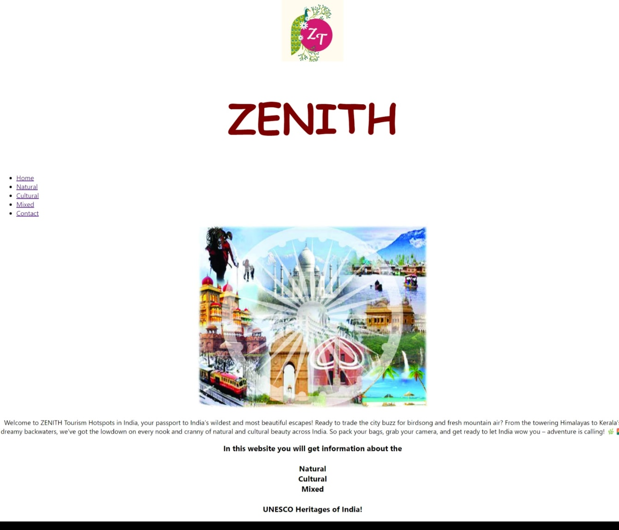



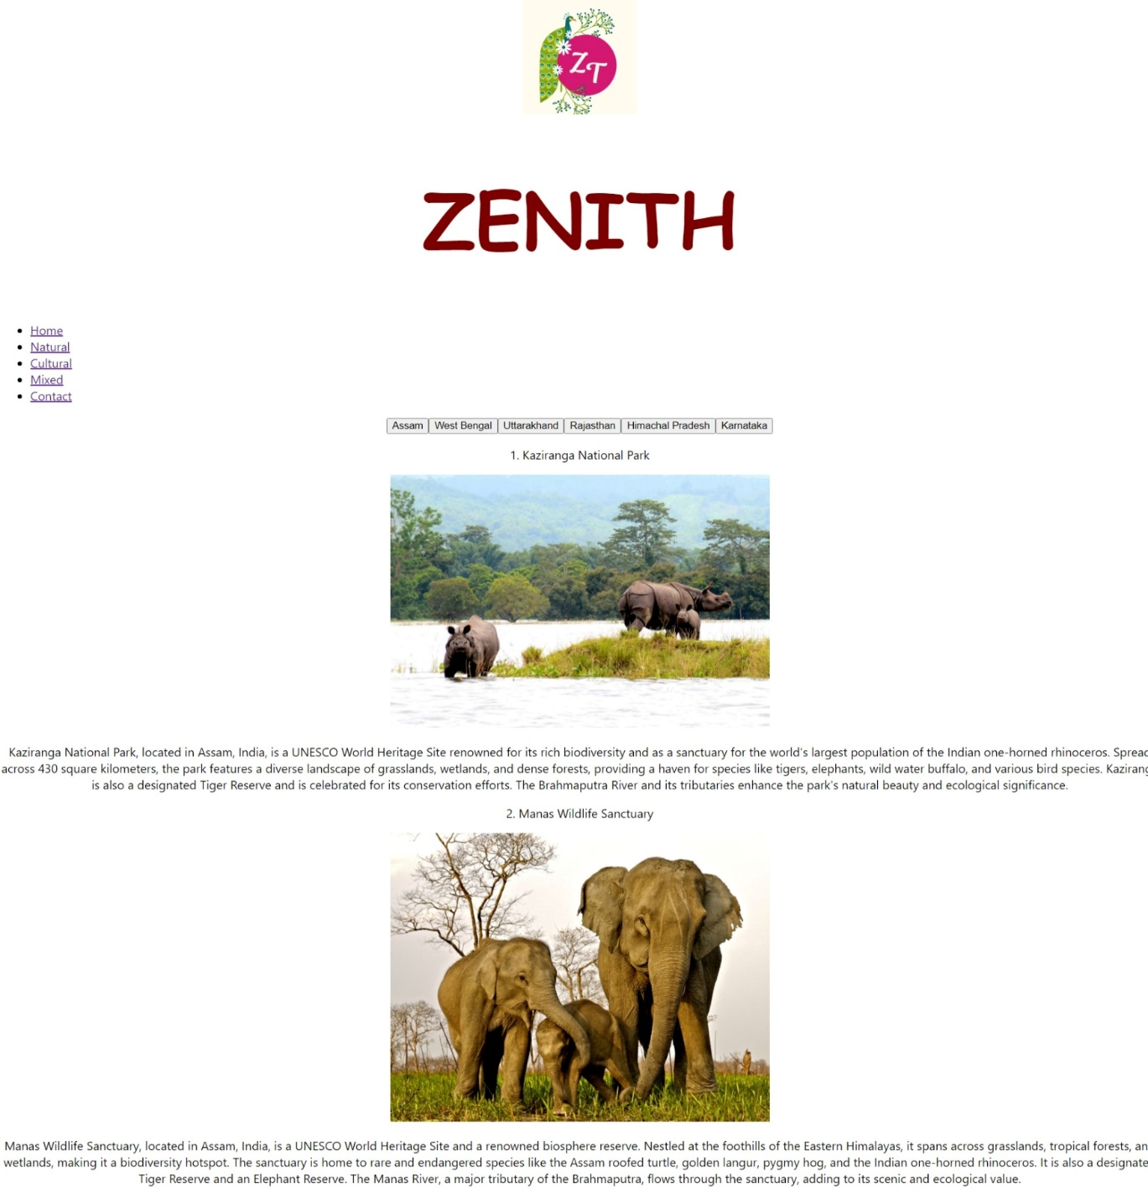



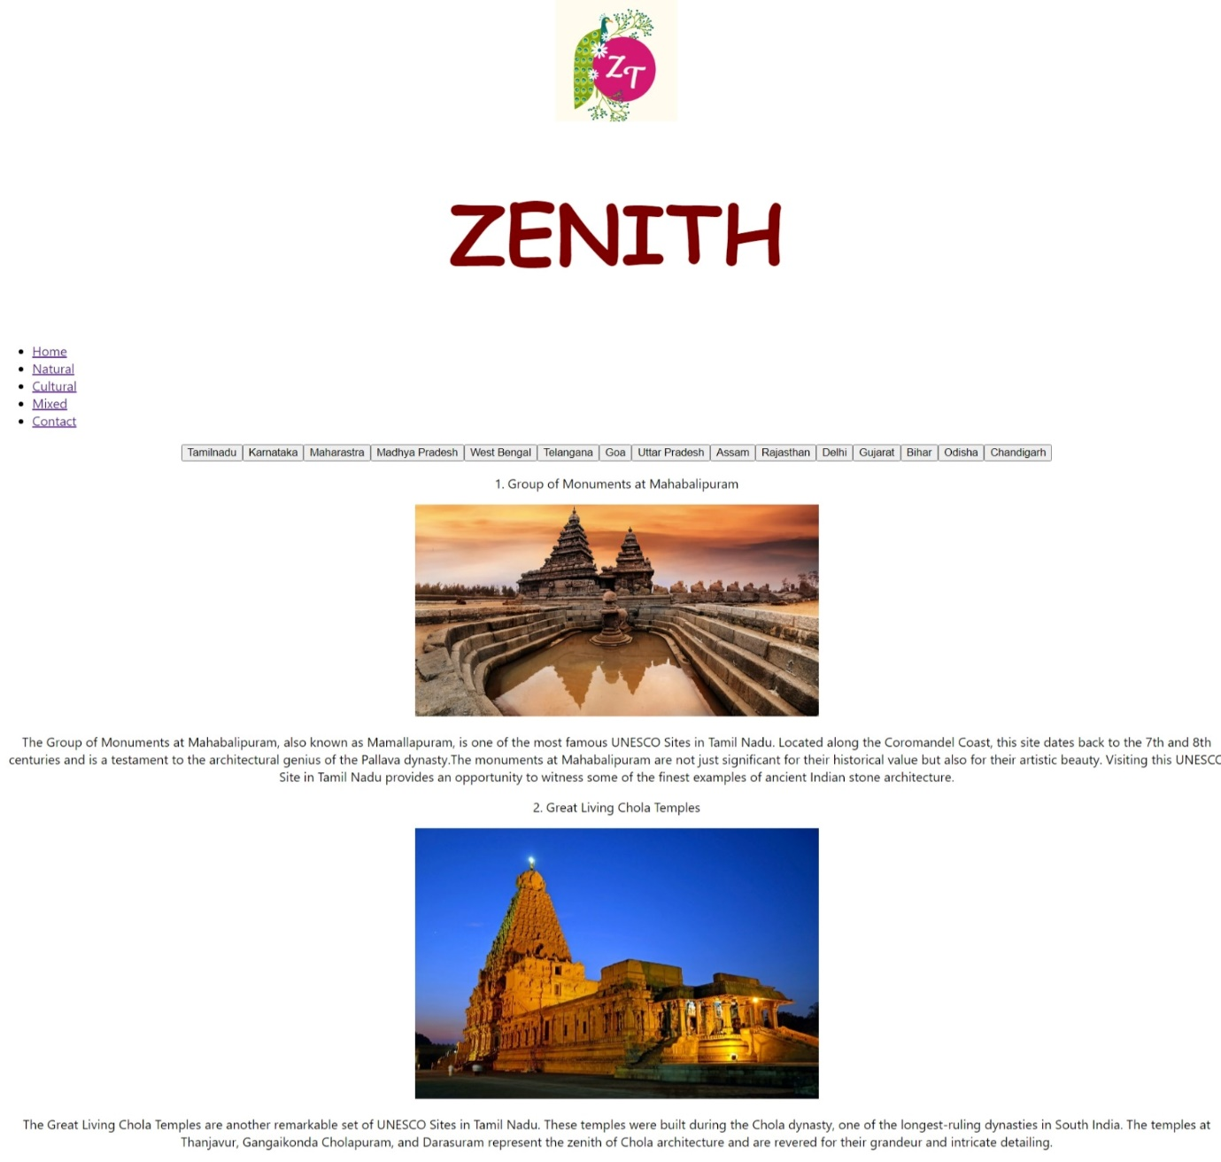****

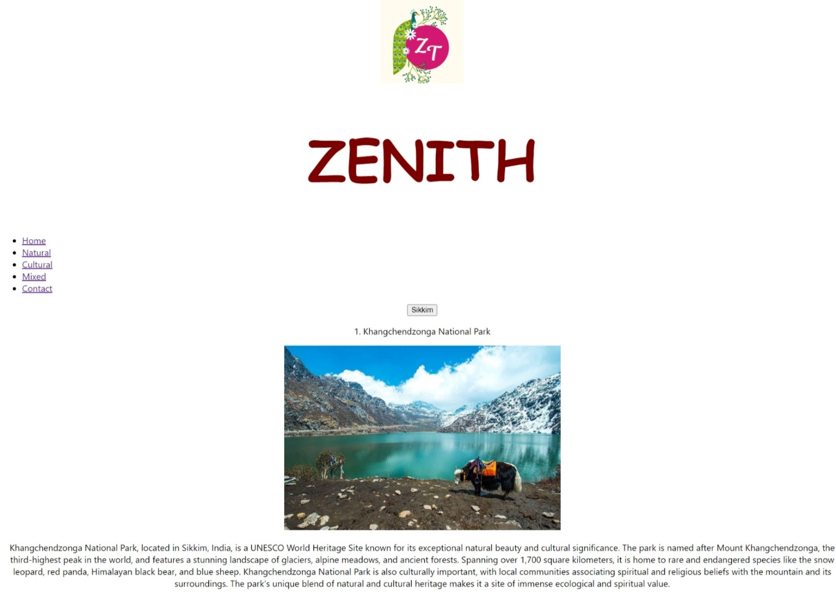

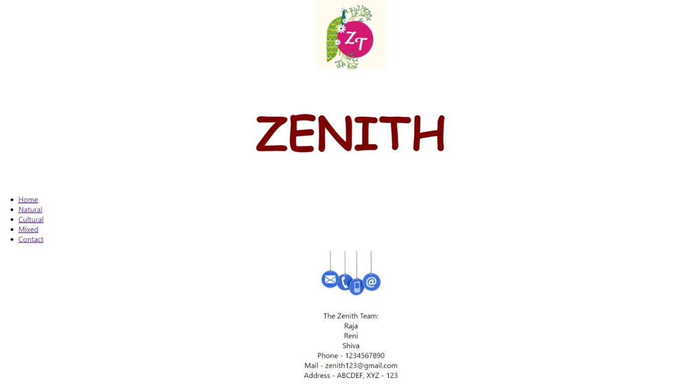

**WHY THIS PROJECT?**

This project, designed as a React-based web application, aims to provide an immersive and interactive platform for exploring India's diverse tourist hotspots. It serves as a comprehensive guide, offering detailed information on both natural and cultural attractions across the country.

***Addressing a Growing Need***

With the increasing popularity of India as a tourist destination, there is a growing demand for user-friendly resources that can help travellers plan their itineraries effectively. This project addresses this need by offering a centralized platform where users can conveniently discover and explore a wide range of attractions.

***Promoting Tourism and Local Economies***

By showcasing India's rich cultural heritage and stunning natural landscapes, this project aims to promote tourism and contribute to the growth of local economies. By providing detailed information about popular attractions, it encourages visitors to explore different regions and support local businesses, such as hotels, restaurants, and transportation services.

***Preserving Cultural Heritage and Natural Beauty***

This project also serves as a valuable tool for preserving India's cultural heritage and natural beauty. By highlighting the significance of various attractions, it raises awareness about their importance and encourages visitors to appreciate and respect these valuable resources.